Spirulina Farming

Introduction 

Spirulina is a type of bacteria called cyanobacterium commonly known as blue-green algae that grows both in fresh as well as salt water. Similar to plants it produces energy from sunlight through the photosynthesis process. It grows and thrives in warm water alkaline ponds and rivers. Protein is one of the important components in a diet. It is one of the best potential sources of protein. This protein in Spirulina is grown commercially in large-scale culture systems for human as well as animal consumption. Spirulina contains 40 to 80% protein content and its growth rate is very high. For its growth, it requires less water, land, and can grow in any climate in tropical regions. In commercial aquacultures such as fish, prawn, and livestock; Spirulina either in the wet or dried form is used as a complementary dietary ingredient. Spirulina is unicellular, filamentous blue-green algae coiled in spirals of varying tightness and numbers measuring about 0.1 mm. In environments having adequate minerals, it grows rapidly with high nutrient content, low nucleic acid content, high concentrations of vitamins, and minerals. In developing countries, it is used as a potential source of food, feed, and fuel. For human nutrition, it is cultivated in large scale in clean waters and under controlled conditions while it is also grown in wastewaters and can be used in animal feed. At the bottom of article, you can find cost and profit details in Spirulina Farming Project Report.

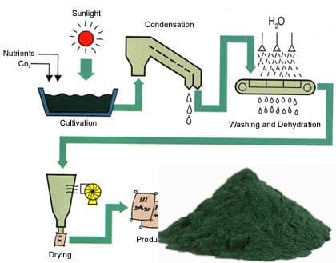

**Scientific / Botanical Name of Spirulina**

The scientific name of domesticated Spirulina is known as Crocus sativus L. from the family Iridaceae.

**Spirulina Health Benefits**

•  Spirulina contains many nutrients in high concentrations.

•  Contains antioxidant and anti-inflammatory properties.

•  It is good for the heart as it can lower LDL and triglyceride levels.

•  Stops LDL cholesterol in becoming oxidized.

•  Appears to have anti-cancer properties and works well against oral cancer.

•  Controls inflammation in the nasal airways (allergic rhinitis symptoms).

•  Effective against anemia.

•  Useful for HIV patients as it strengthens the immune system.

•  Improves muscle strength and endurance.

•  Boosts brain energy as it increases Ribonucleic acid. Studies in animals showed lowering of blood sugar levels.

•  Improves digestive system health.

•  Have properties against anti-aging.

•  A tablespoon contains: 4 grams of protein, Vitamin B1 (Thiamin11 % of RDA), Vitamin B2 (Riboflavin 15% of RDA), Vitamin B3 (Niacin 4% of RDA), Copper (21% of RDA), Iron (11% of RDA), also contains Omega-6 & Omega-3 fatty acids (about 1 gram), manganese, potassium, and magnesium.

**Growing Conditions of Spirulina**

**Climate**: Spirulina while growing for commercial and large-scale production has to be done in regions with suitable climatic conditions. Tropical and sub-tropical regions are well-suited places for its growing. It requires sunshine throughout the year. The growth rate and production of Spirulina depend on various factors such as wind, rain, temperature fluctuation, and solar radiations.

**Temperature**: For a high production with high protein content, a temperature between 30° to 35° C is ideal. Spirulina can survive in temperatures between 22° to 38° C but the protein content and color will be affected. Bleaching of cultures takes place when temperatures are above 35° C and it cannot survive in temperatures less than 20° C.

**Light**: The intensity of light plays an important role in its growth. Light has a direct effect on protein content, growth rate, and pigment synthesis of Spirulina. The light intensity between 20 to 30 K lux is found to be ideal for Spirulina farming. It is observed under 2 K lux for 10 hours period by providing different light shades; under the blue light, it yielded the highest protein content. Yellow, white, red, and the green light was the next levels of protein generated.

**Stirring**: Spirulina needs exposure to light, as it a photosynthesizing organism. Light is maximum on the top surface, Spirulina that is on top of the culture will thrive well while the ones beneath have a slow growth rate and the Spirulina that remains below may die. For maximum production and proper growth rate of each organism that culture has to be stirred constantly. This helps all organisms reach the top of the culture and photosynthesis takes place uniformly. Stirring can be done manually as well as mechanically. Pump and paddle wheels can be installed and can be powered by solar. Maximum care should be taken while in manual stirring which can be done either with a stick or broom or any other convenient thing. Stirring should be done in slow circular motions in one direction. Manual stirring is carried out once in every two to three hours in daytime only. After every stirring, the instruments are cleaned thoroughly before.

**Water Quality**: In commercial Spirulina farming, it is required to recreate the close culture medium in which blue-green algae grows naturally. Water is the main source medium for Spirulina to grow. It should have all the necessary sources of nutrition for a healthy growth of Spirulina. The ideal water quality should be maintained throughout the micro-algaemass production by providing a controlled salt solution in the water. The ideal pH value culture medium should be between 8 to 11 ranges. The water level in tanks or pits should be controlled. The water level is important for the photosynthesis process to take place in all organisms. The deeper the water level, sunlight penetration will be reduced, which will affect algae growth. A minimum shallow level of 20 cm is ideal water level height. The chemical composition of the culture medium is as follows: 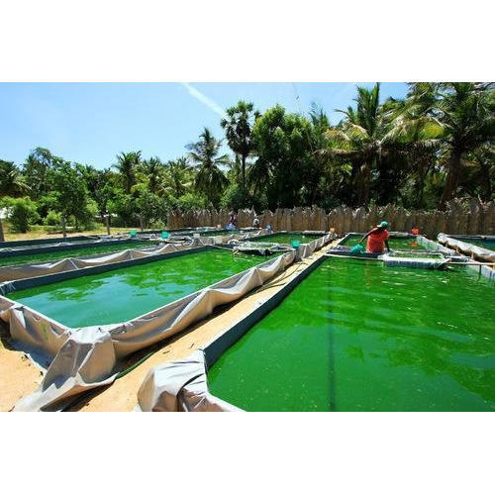

|  |  |
| --- | --- |
| **Chemical Component** | **Concentration (Grams Per Liter)** |
| Sodium Hydrogen Carbonate (NaHCO3) | 8.0 |
| Sodium Chloride (NaCl) | 1.0 |
| Potassium Nitrate (KNO3) | 2.0 |
| Hydrous Magnesium Sulphate (MgSO4.6H2O) | 0.16 |
| Ammonium Phosphate ((NH4)3PO4) | 0.2 |
| Urea (CO(NH2)2) | 0.015 |
| Sulphate Hepta hydrate (FeSO4.6H2O) | 0.005 |
| Iron Potassium Sulphate (K2SO4) | 1.0 |
| Calcium Chloride Dihydrate (CaCl2.2H2O) | 0.1 |
| Ammonium Cyanate (CH4N2O) | 0.009 |

**Contamination**: Contamination of culture medium will have a direct effect on the production of Spirulina. The contamination can happen either by insect breeding, foreign algae or through chemical contaminants. Any amount of chlorine present in the water will kill the algae growth. This will lead to a complete loss in the production of Spirulina. Larva of mosquitoes and other insects will feed on algae leading to about an overall 10% decrease in production. At the time of harvesting, the existence of larva or pupae will contaminate the Spirulina quality and yield. All extraneous materials can be removed from the culture medium by using a fine wire mesh frame.

**Spirulina Cultivation and Production**

**Natural Habitat**: Spirulina is one among many algal species found growing in natural freshwaters. They are also found in natural habitats such as soil marshes, seawater, and brackish waters where alkaline waters exist. They thrive well in highly alkaline waters with a high level of solar radiation where no other microorganisms can grow. They can also tolerate low temperatures 15° C during nights and 40° C for a few hours in the daytime. In the natural habitats, their growth cycles depend on the limited supply of nutrients. When new nutrients from the rivers or from pollution reach the water bodies, the algae rapidly grows and increase its population to the maximum density. When nutrients get exhausted the Spirulina dies off reaching the bottom and gets decomposed releasing nutrients into the water. A new Spirulina cycle begins when more nutrients flow into the lake.

**Commercial and Mass Cultivation**: Japan in the early 1960's started large-scale culture cultivation of microalgae of chlorella followed by Spirulina in the early 1970's. Today, there are more than 22 countries that cultivate Spirulina commercially on a large-scale.

**Ponds**: Commercial cultivation is usually carried out in shallow artificial ponds equipped with mechanical paddle wheels for stirring the culture. The cultivation is carried out in two ways. 1. Concrete ponds and 2. Pits lined with PVC or other plastic sheets. Concrete ponds can last for very long mass cultivation, but it is very expensive. The cost of production in the early years will be high. Low-cost clay sealing and durable plastic sheets will not last long, but incur investment at regular periods when the materials start to wear and tear. Concrete ponds will be more cost-effective in the Spirulina business over the years while low-investment structures will be more expensive in the business over the years. Ponds can be of any size and shape depending on the physical land dimensions. Construction of single or multiple ponds can be done with each pond size of 50 m long, 2-3 m wide, and with 20 to 30 cm depth are ideal pond conditions. Length of the ponds can be of any length depending on the land availability. Covering of each pond with transparent polythene covers will help increase the temperature, decrease water evaporation, and helps reduce chances of contamination.

**Mixing Devices**: There are two ways of mixing the culture evenly and they are manual mixing the culture and mixing the culture mechanically. Hand tools, such as long sticks, or broomsticks, or any convenient devices can be used. Commonly used mechanical devices are paddle wheels, these are installed for stirring the culture. Stirring the culture helps all the Spirulina organisms reaching to the top that they can take carbon dioxide and solar energy for photosynthesis. Paddle wheels are installed according to the size of the ponds. A large paddle wheel of diameter about two meters should rotate at 10 rpm speed. A small paddle wheel of diameter up to 0.7 meters can rotate at 25 rpm speed for proper culture stirring.

**Spirulina Cultivation Process**: Cultivation can be started after water is fed into each concrete pond at a required height and after paddle wheels are installed. The water has to have the right pH value and alkaline by adding required salts at the required rate. Once the water has a standard micronutrient composition, the pond is ready for Spirulina seeding. Ideally, for uniform growth and for uniform harvesting, 30 grams of dry Spirulina is added for every 10 liters of water. A concentrated live Spirulina culture can also be used as seeding the pond. In commercial farms, one pond is exclusively kept for rearing Spirulina as seed. This will reduce the regular purchase and the farm becomes self-sustain and also can sell live Spirulina seed to other farmers. The algae bacterium starts to double in biomass within three to five days. The alga thrives growing by consuming the nutrients in the culture medium. Farmers have to continually check the nutrient content value and adding fresh water at regular periods for good production and for top yields. Farmers should be alert to control environmental conditions as this prevents the culture medium from contamination. Cultures grow rapidly as well as perish rapidly when Spirulina cultures are not taken care of properly. The matured Spirulina changes from light to dark green in color. The concentration of algae and color of the algae is the deciding factor for when Spirulina should be harvested. The other way is by using Secchi desk to measure and it should be around 0.5 grams per liter of culture medium.

The water level in the pond should be maintained at 20 to 30 cm (25 cm is ideal water level height). As most of the ponds are open the evaporation of water will affect the cultivation. Especially during summer, on an average thrice in a month, fresh water is released into the ponds to maintain consistent (25 cm) water level height throughout the cultivation.

**Harvesting of Spirulina**

**Filtering of Culture Medium**: As said earlier, the concentration of algae in the pond will be the deciding factor for harvesting. In general, the pond will be ready for harvest after five days after seeding process is done. Different farmers use different methods to harvest Spirulina, this is because of the availability of material resources and finance. Whatever is the reason, filtration is carried out to harvest Spirulina. Culture is collected in a container and poured onto the cloth. The culture medium flows back into the pond, leaving Spirulina on the cloth. The excess or the culture medium residues that still remains can be drained by applying pressure or squeezing. Farmers have designed various filtering process for the easy and quick process. One can get more information on the internet for various designs that can be used to reduce manual and quick harvest processing work. After filtering, the collected Spirulina is thoroughly washed in distilled water to remove any traces of salts, contaminants, or culture medium residue. Once the cleaning is done, the water content is further removed by squeezing or pressing and is ready for drying. Freshly harvested Spirulina will be at its best in its nutritional values. Fresh Spirulina cannot last more than 2 days, hence it needs to be dried to preserve its nutritional values and to last for a longer duration.

**Drying of Fresh Spirulina**: Spirulina, when dried, will last for many months and also the nutritional content in it can be preserved. For quick drying, the Spirulina mass is kept inside the kitchen press grater and then pressed into thin strands on a long clean cloth under the sun. This helps in quick drying. The kitchen press comes with various discs of different hole sizes in it. Use the disc which is comfortable and which will help in quick drying. The Spirulina mass is squeezed into thin strands through machines which are used for noodles and are laid in the open sun to dry. Some farmers apply the Spirulina mass into a thin layer using a knife over the cloth. Some uses syringe for noodle-like strands. Whatever methods and materials used, shortening the drying period will lessen contaminators. Ovens that run electrically or solar powered can be used to speed drying. The temperature in the oven when maintained at 60° C takes about 4 fours while 40° C takes about 15 to 16 hours for Spirulina drying.

Grinding and Storage: The well-dried strands of Spirulina are now ready for grinding. Grinding machines for flour making can be used for grounding of the dried algae. Spirulina is grounded and made into soft powder dust which is then packed with different weights and sealed for marketing. Vacuum dried and airtight packing will preserve the nutritional qualities up to three to four years.

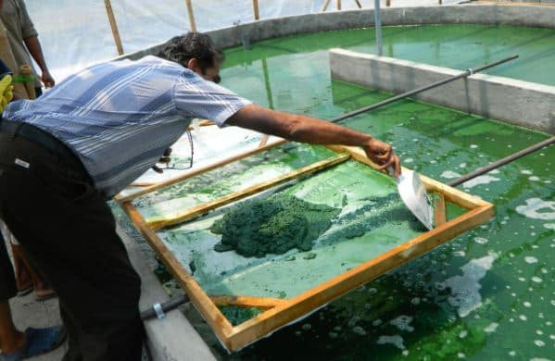

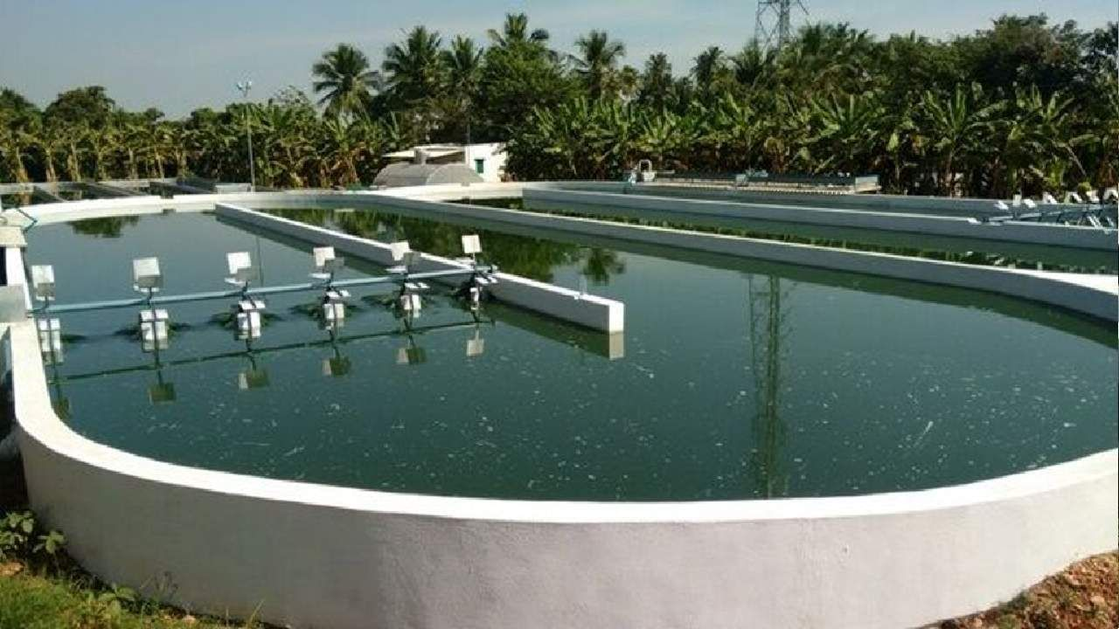

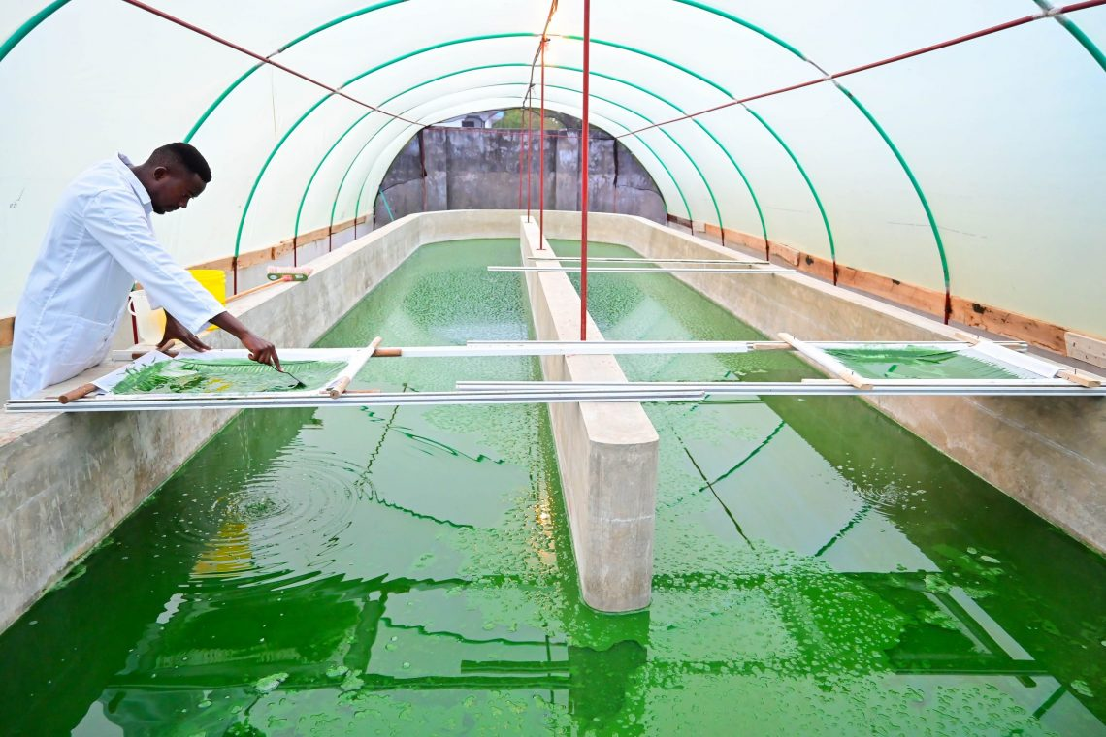

**Cost and Profits in Spirulina Farming / Spirulina Farming**

**Economics of Spirulina Farming**: This project report is to give entrepreneurs a general overview of investment and revenues and the figures mentioned are not actuals but for a business understanding. Each pond constructed is of 10 x 20 feet size. And there are about 20 such ponds. Each pond will generate on an average about 2 kg wet culture per day. The farmer has to understand this equation that a one-kg wet culture will give 100 grams of dry powder only. Based on this, on an average, a 20 tank Spirulinafarming business will generate 4-5 kg of dry Spirulina powder on a daily basis. The production of Spirulina in a month will be around 100 to 130 kg per month. Dry Spirulina powder in the market will fetch about Rs. 600/- per kg. A farmer can earn about 40-45,000/- per month. A farmer can reduce his fixed investment by going for earth pits covered with durable plastic sheets which can cost him around Rs. 3-4.5 lakhs. A farmer can make more profits by increasing tanks made with low-cost, durable materials apart from concrete ponds by utilizing maximum space available in the land, which will reduce labor and investment with more profit returns.

**Capital Investment Cost**

|  |  |  |
| --- | --- | --- |
| **S. No** | **Particulars** | **Cost Rs** |
| 1 | Pond Construction (5 @ 50,000/-) | 2,50,000 |
| 2 | Plant Machinery | 25,000 |
| 3 | Laboratory Equipment | 5,000 |
| 4 | Water Treatment Plant | 1,50,000 |
| 5 | Piping Work | 25,000 |
| 6 | Electrical Works | 25,000 |
| 7 | Drying Screens | 20,000 |
| 8 | Harvesting Screens | 10,000 |
| 9 | Packing Materials | 5,500 |
| 10 | Chemicals (per month) | 2,000 |
| 11 | Labor (monthly basis) | 18,000 |
| 12 | Miscellaneous | 2,500 |
| **Total Capital Investment** | | 5,38,000 |

|  |  |  |
| --- | --- | --- |
| **S. No** | **Particulars** | **Cost Rs** |
| 1 | Total Capital Investment | 5,38,000 |
| 2 | Operational Cost on a monthly basis | 35,000 |
| **Total Cost** | | **5,73,000** |

**Income**

|  |  |  |
| --- | --- | --- |
| **S. No** | **Particulars** | **Cost Rs** |
| 1 | Sale of Spirulina Powder @ Rs. 600 per kg | 72,000 |
| **Incomep.m (Sale – Operational Cost)** | | **47,000** |

**Spirulina Quality Specifications**

The end product will fetch about 600 to 650/- per kg if the following quality specifications are met.

|  |  |  |
| --- | --- | --- |
| **S. No** | **Particulars** | **Quality %** |
| 1 | Moisture | 3% |
| 2 | Protein | 65% |
| 3 | Fat | 7% |
| 4 | Crude Fiber | 9% |
| 5 | Carbohydrates | 16% |
| 6 | Energy (100 gms) | 346 KCal |
| 7 | Mold & Fungus | Nil |
| 8 | Coliforms, Salmonella, streptococci bacteria, and fermented odor | Nil |

**Tips and Challenges in Growing Spirulina**

•  Maintain uniform nutrient content in the culture medium throughout the cultivation.

•  Maintain culture medium temperature and 20-25 cm height level in the pond.

•  Thorough stirring of culture medium gently in one direction should be carried out once in three to four hours in the daytime.

•  Avoid contamination of culture medium.

•  Mosquito larva will destroy 10% production by feeding on it.

•  The protein content of 65% will fetch market value, to achieve this; nutrient content in the culture medium should be maintained consistently throughout the cultivation.

•  Direct sunlight should be available for healthy growth.

•  Freshwater is provided when the pond starts to smell ammonia.

•  Thick green layer formation indicates a delay in harvesting.

•  Dried Spirulinapowder is stored immediately in an airtight satchets.

